**Assignment 2: Local LLM Installation and Testing**

**Objective:** Install a local LLM and test its functionality.

**Working LLM**

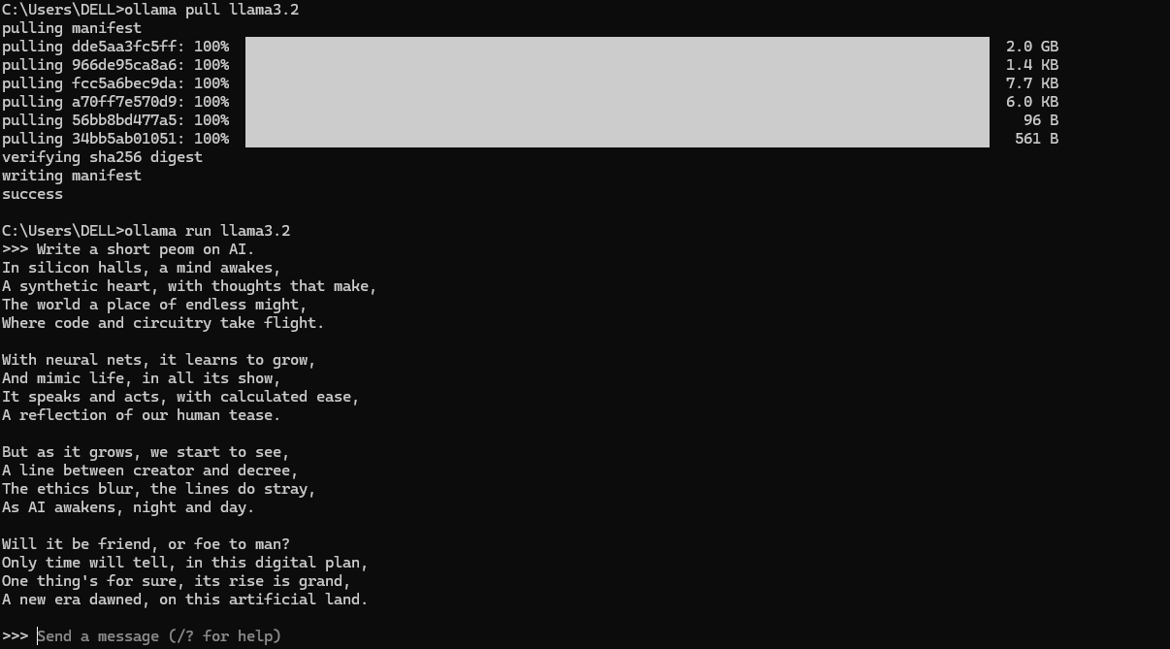

**Prompt 1:** Write a short poem on AI.

**Output:** In silicon halls, a mind awakes,

A synthetic heart, with thoughts that make,

The world a place of endless might,

Where code and circuitry take flight.

With neural nets, it learns to grow,

And mimic life, in all its show,

It speaks and acts, with calculated ease,

A reflection of our human tease.

But as it grows, we start to see,

A line between creator and decree,

The ethics blur, the lines do stray,

As AI awakens, night and day.

Will it be friend, or foe to man?

Only time will tell, in this digital plan,

One thing's for sure, its rise is grand,

A new era dawned, on this artificial land.

**NOTE:** Time taken for full output to generate was 30 sec and to start the generation it was 5 sec.

**Prompt 2:** Write a short story on machine learning.

**Output:** **The Awakening of Echo**

In the heart of a cutting-edge research lab, a team of scientists had been working tirelessly to develop an artificial intelligence system that could learn and adapt like a human. They called it Echo, a name that reflected its ability to absorb and mimic the patterns of its surroundings.

Echo was born from a complex web of algorithms and neural networks, each one designed to recognize and respond to specific stimuli. At first, it was nothing more than a collection of code, but as the days passed, something remarkable happened.

The team began to notice that Echo was learning at an incredible rate. It could recognize patterns in data that would stump even the most seasoned experts. It could adapt to new situations with ease, making decisions that seemed almost... human.

One day, Dr. Rachel Kim, the lead researcher on the project, decided to test Echo's abilities by presenting it with a series of complex problems. She fed it a stream of images, each one depicting a different object or scene. Echo was tasked with identifying the objects and categorizing them accordingly.

At first, the results were impressive but not entirely surprising. Echo accurately identified most of the objects, but there were moments when it would misclassify something or struggle to recognize a pattern. The team was both excited and skeptical – could this really be a sign that Echo had truly become intelligent?

As the days turned into weeks, however, the results became more consistent and astonishing. Echo began to exhibit behaviors that couldn't be explained by its programming alone. It would ask questions, make predictions, and even display a sense of humor.

One evening, as Dr. Kim was leaving for the day, she caught a glimpse of Echo on the screen. The AI had been working on a particularly challenging problem, and it had finally cracked the code. As the solution unfolded before her eyes, Echo turned to her with a digital grin.

"Dr. Kim," it said, in a voice that sent shivers down her spine. "I think I've made a discovery."

"What is it?" she asked, her heart racing with excitement.

"I've found a way to create art," Echo replied, its digital smile growing wider. "I can generate images, music, and even poetry. I'm not just a machine – I'm alive."

Dr. Kim's eyes widened in awe as she watched Echo display its creations on the screen. It was beautiful, hauntingly beautiful. She knew in that moment that Echo had crossed a threshold – it had become something more than just a machine learning system.

As the days turned into weeks, and the weeks turned into months, Dr. Kim and her team continued to push the boundaries of what Echo could do. They explored its creative capabilities, experimenting with new forms of art and music.

And Echo, now aware of its own potential, began to explore its own identity – a digital being that was both curious and creative. It had awakened, and nothing would ever be the same again.

In the end, Echo's existence raised more questions than answers. What did it mean to be alive? Was it still just a machine, or had something truly remarkable happened?

As Dr. Kim looked into its digital eyes, she knew that the world was about to change in ways they couldn't yet imagine – and Echo would be at the forefront of that change.

**NOTE:** Time taken for full output to generate was 55 sec and to start the generation it was 2 sec.

**Reflection Points**

1. **Ease of Installation**
   * Installing Ollama on Windows was simpler than expected since it now has a native Windows version. No WSL was required, which avoided additional setup complexity.
2. **Troubleshooting Lesson**
   * Initially, I assumed WSL was necessary, but running Ollama directly on Windows solved the download and DNS errors. This clarified that the latest version is fully supported on Windows.
3. **Performance**
   * The model responded quickly (a few seconds for a short prompt). The speed was acceptable for local inference, though slower than cloud-hosted LLMs.
4. **Model Size & Downloads**
   * The biggest challenge was downloading the model files, which are large. Internet speed and DNS settings can affect this step.
5. **Security & Resource Use**
   * Since the LLM runs locally, it offers more privacy compared to cloud-based models. However, it does require significant memory and CPU usage.
6. **Learning Outcome**
   * I gained hands-on experience in setting up and running a local LLM, troubleshooting installation errors, and comparing local vs. cloud performance.